**Method Design**

**Class name:** CartController (CD-01)

**Package:** Controller

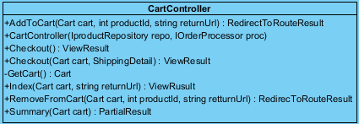

**Description**

**Method name:** AddToCart

**Description:** This method will add the product to cart.

**Parameters:** Cart cart, int Product, string returnUrl

**Method name:** CartController

**Description:** This method will control cart

**Parameters:** IProductRepository repo, IOrderProcessor proc

**Method name:** Checkout

**Description:** This method will insert summary of cart.

**Parameters:** Cart cart, ShippingDetail

**Method name:** GetCart

**Description:** This method will get the infomation of cart.

**Parameters:** -

**Method name:** Index

**Description:** This method will show viewresult.

**Parameters:** Cart cart, string returnUrl

**Method name:** RemoveFromCart

**Description:** This method will remove the product from cart.

**Parameters:** Cart cart, int productId, string returnUrl

**Method name:** Summary

**Description:** This method will show detail in cart.

**Parameters:** Cart cart

**Class name:** NavController (CD-02)

**Package:** Controller



**Description**

**Method name:** Menu

**Description:** This method will show the menu provide type of product.

**Parameters:** -

**Method name:** NavController

**Description:** This method will get the product from IProductRepository.

**Parameters:** IProductRepository repo

**Class name:** AdminController (CD-03)

**Package:** Controller

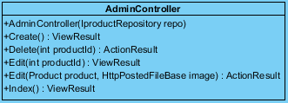

**Description**

**Method name:** AdminController

**Description:** This method will get the admin from IProductRepository.

**Parameters:** IProductRepository repo

**Method name:** Create

**Description:** This method will the admin create the product to product repository.

**Parameters:** -

**Return:** Product catalog with new product.

**Method name:** Delete

**Description:** This method will the admin delete the product leave out product repository.

**Parameters:** -

**Return:** Product catalog without delete’s product.

**Method name:** Edit

**Description:** This method will the admin edit the detail of product in product repository.

**Parameters: int** productId

**Return:** Product catalog with new detail of product.

**Method name:** Index

**Description:** This method will show index page.

**Parameters: -**

**Return:** Index page

**Class name:** ProductController (CD-04)

**Package:** Controller

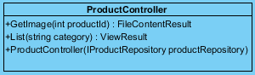

**Description**

**Method name:** GetImage

**Description:** This method will get the image of product.

**Parameters:** int productId

**Method name:** List

**Description:** This method get product catalog

**Parameters:** string category

**Method name:** ProductController

**Description:** This method will get the product from IProductRepository.

**Parameters:** IProductRepository productRepository

**Class name:** AccountController (CD-05)

**Package:** Controller

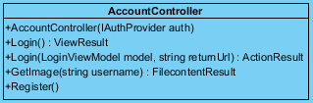

**Description**

**Method name:** AccountController

**Description:** This method will control account.

**Parameters:** IAuthProvider auth

**Method name:** Login

**Description:** This method show the login page

**Parameters:** LoginViewModel model, string returnUrl

**Method name:** GetImage

**Description:** This method will get the image of customer.

**Parameters:** string username

**Class name:** Cart (CD-06)

**Package:** Model

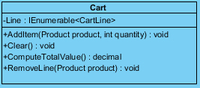

**Description**

**Method name:** AddItem

**Description:** This method will add the product in to cart.

**Parameters:** Product product, int quntity

**Method name:** Clear

**Description:** This method set the cart null

**Parameters:** -

**Method name:** ComputeTotalValue

**Description:** This method will calculate the value of product in cart.

**Parameters:** -

**Method name:** RemoveLine

**Description:** This method will set the cartline to null.

**Parameters:**Product product

**Class name:** IOrder Repository (CD-07)

**Package:** Abstract



**Description**

**Method name:** ProcessOrder

**Description:** This method will save the summary of cart.

**Parameters:** Cart cart, ShippingDetail shippingDetail

**Class name:** IProductRepository (CD-08)

**Package:** Abstract

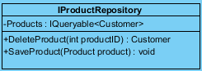

**Description**

**Method name:** DeleteProduct

**Description:** This method will delete product from database table.

**Parameters:** int productID

**Method name:** SaveProduct

**Description:** This method will save or add product and detail to database table.

**Parameters:** Product product

**Class name:** IAccountRepository (CD-09)

**Package:** Abstract

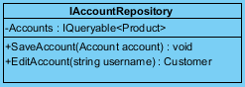

**Description**

**Method name:** SaveAccount

**Description:** This method will save or add ccount and detail to database table.

**Parameters:** Account account

**Method name:** EditAccount

**Description:** This method will edit account in database table.

**Parameters:** string username